Note: All pixels are normalized between 0 and 1. The differences are taken as the average of abs(original_image-denoised_image).

**Image Number 1 (First image in the dataset “data”) Results:**

*Original Image Changes:*

Average change with TomoGAN is 0.1183 (Original image – denoised image with TomoGAN)

Average change with CNN is 0.01808 (Original image – denoised image with CNN)

*Adding and Removing Poisson noise:*

Average pixel value difference by introducing Poissan noise is 0.06053 ((Original image + Poisson noise) - Original image)

TomoGAN

Average difference in pixel values between the original image and denoised image is 0.02463 (Original image – TomoGAN denoised image)

Average difference in pixel values between the poisson added image and denoised image is 0.06298 (Poisson added image – TomoGAN denoised image)

CNN

Average difference in pixel values between the original image and denoised image is 0.09478 (Original image – CNN denoised image)

Average difference in pixel values between the poisson added image and denoised image is 0.1291 (Poisson added image – CNN denoised image)

**Image Number 700 Results:**

*Original Image Changes:*

Average change with TomoGAN is 0.1447 (Original image – denoised image with TomoGAN)

Average change with CNN is 0.1432 (Original image – denoised image with CNN)

*Adding and Removing Poisson noise:*

Average pixel value difference by introducing Poissan noise is 0.05947 ((Original image + Poisson noise) - Original image)

TomoGAN

Average difference in pixel values between the original image and denoised image is 0.02598 (Original image – TomoGAN denoised image)

Average difference in pixel values between the poisson added image and denoised image is 0.06298 (Poisson added image – TomoGAN denoised image)

CNN

Average difference in pixel values between the original image and denoised image is 0.1043 (Original image – CNN denoised image)

Average difference in pixel values between the poisson added image and denoised image is 0.13786 (Poisson added image – CNN denoised image)

*Analysis:*

For the first image, TomoGAN removed noise much more aggressively than CNN. For the second image, they removed noise at similar levels. Since we don’t have the noise-free image, we can’t judge whether they effectively removed the noise or some of the image’s original content. However, since CNN performed differently in both images, we can deduce that CNN is more responsive to a certain type of noise that was absent in the first image. TomoGAN also removed less noise in the first image, suggesting it may be sensitive to that noise, although not as much as CNN.

When Poisson noise is introduced to the images, the average pixel value difference is approximately 0.06 for both images. TomoGAN makes changes to the pixels at a similar level (0.063), and the end results closely resemble the original images, with an average difference of only 0.025 in pixel values. This indicates that TomoGAN consistently performs well in removing Poisson noise.

On the other hand, CNN makes changes to the images approximately twice as much as TomoGAN (~0.06 vs. ~0.12), but the end result is four times worse than that of TomoGAN (~0.025 vs. ~0.1). However, we can't definitively conclude that CNN performs poorly in removing Poisson noise, as we lack knowledge about the original image's noise structure. CNN might also be removing some inherent noise from the original image. Despite the differences from the original image, it could be significantly cleaner in terms of noise.

**Image Number 883 (image with the highest variation among pixels) Results:**

*Original Image Changes:*

Average change with TomoGAN is 0.1177 (Original image – denoised image with TomoGAN)

Average change with CNN is 0.1836 (Original image – denoised image with CNN)

*Adding and Removing Poisson noise:*

Average pixel value difference by introducing Poissan noise is 0.0543((Original image + Poisson noise) - Original image)

TomoGAN

Average difference in pixel values between the original image and denoised image is 0.04514 (Original image – TomoGAN denoised image)

Average difference in pixel values between the poisson added image and denoised image is 0.0553 (Poisson added image – TomoGAN denoised image)

CNN

Average difference in pixel values between the original image and denoised image is 0.1079 (Original image – CNN denoised image)

Average difference in pixel values between the poisson added image and denoised image is 0.0965 (Poisson added image – CNN denoised image)

**Image Number 469 (image with the lowest variation among pixels) Results:**

*Original Image Changes:*

Average change with TomoGAN is 0.11728 (Original image – denoised image with TomoGAN)

Average change with CNN is 0.18786 (Original image – denoised image with CNN)

*Adding and Removing Poisson noise:*

Average pixel value difference by introducing Poissan noise 0.04813 ((Original image + Poisson noise) - Original image)

TomoGAN

Average difference in pixel values between the original image and denoised image is 0.03125 (Original image – TomoGAN denoised image)

Average difference in pixel values between the poisson added image and denoised image is 0.05959 (Poisson added image – TomoGAN denoised image)

CNN

Average difference in pixel values between the original image and denoised image is 0.11713 (Original image – CNN denoised image)

Average difference in pixel values between the poisson added image and denoised image is 0.124985 (Poisson added image – CNN denoised image)

***Images:***

**Image Number 1 (First image in the dataset “data”) Results:**

**Original Image:**

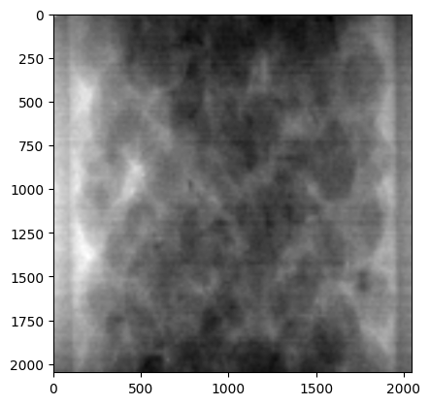

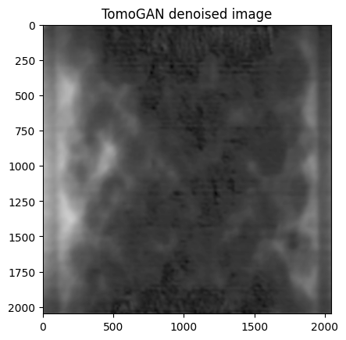

Original and CNN denoised image:

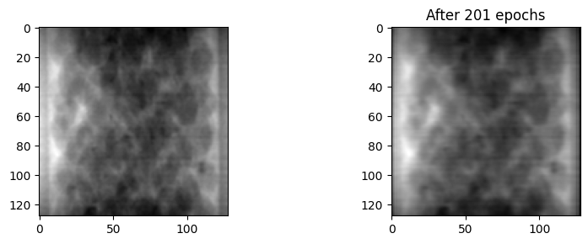

Image of Removed Noise (TomoGAN)

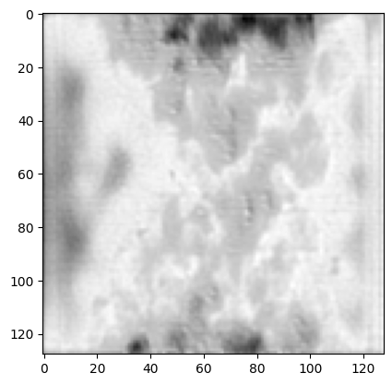

Denoised Image (TomoGAN):

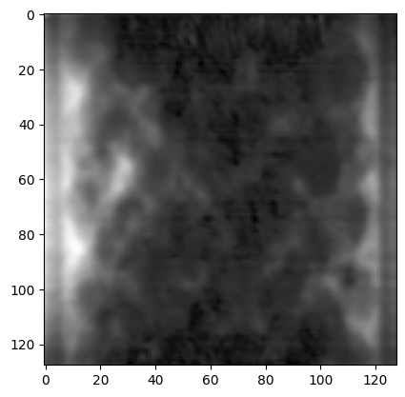

Image of Removed Noise (CNN):

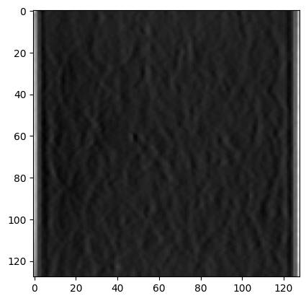

Denoised Image (CNN):

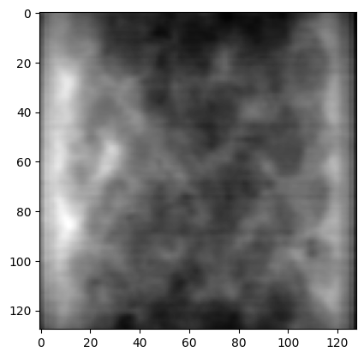

**Adding and Removing Poisson Noise:**

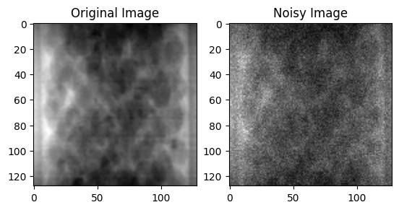

Image after Removing Poission (TomoGAN):

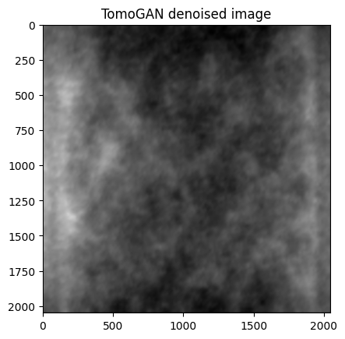

Image after Removing Poisson (CNN):

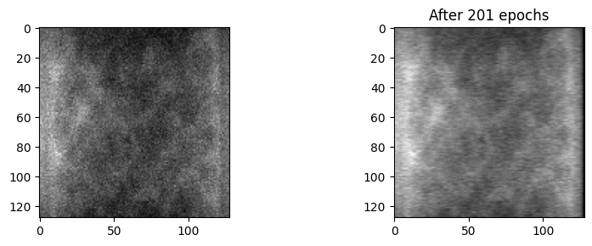

Magnitude Spectrums:

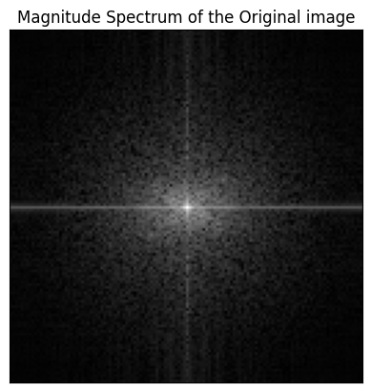

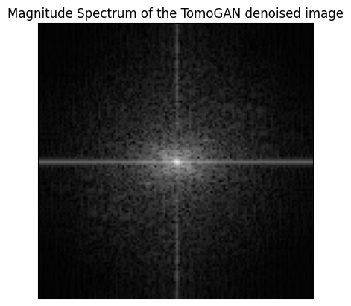

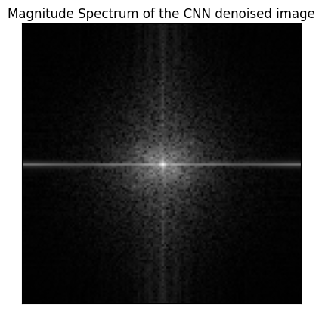

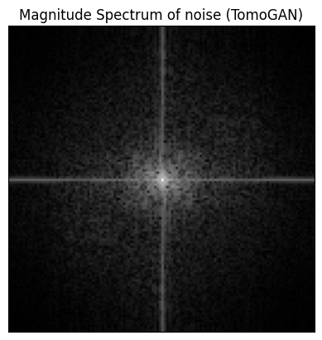

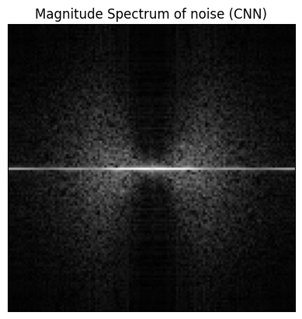

**Image Number 700 Results:**

**Original Image:**

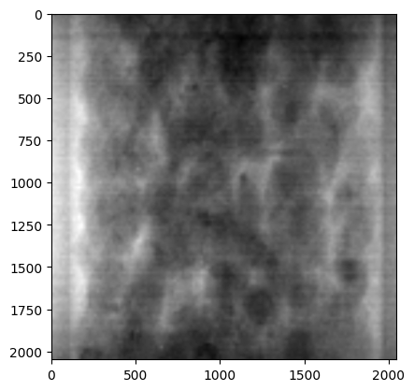

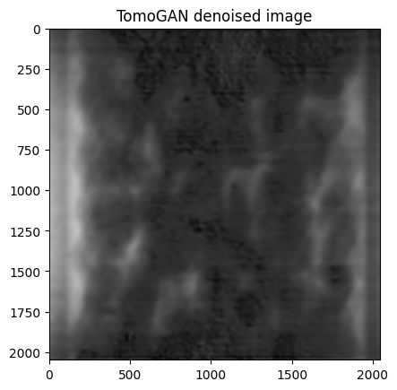

**Original and CNN Denoised Image:**

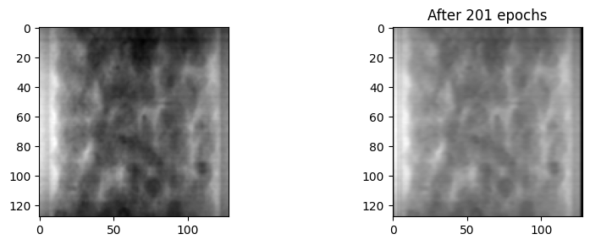

Image of Removed Noise (TomoGAN)

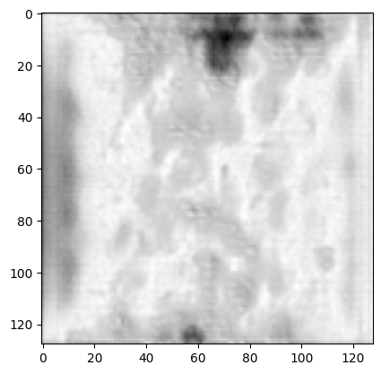

**Denoised Image (TomoGAN)**

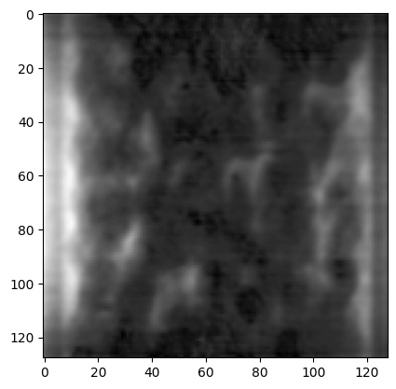

**Image of Removed Noise (CNN)**

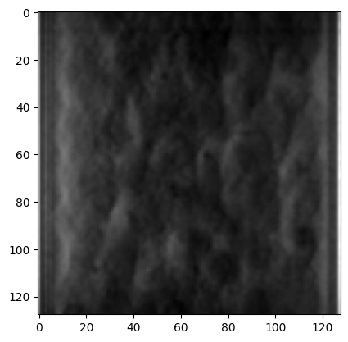

**Denoised Image (CNN)**

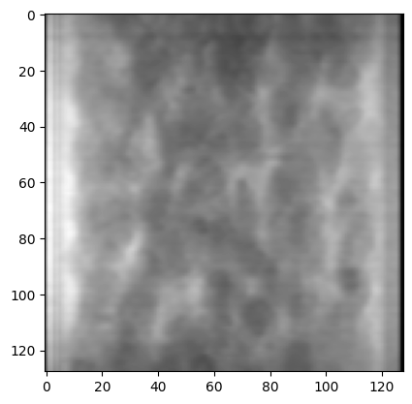

**Adding and Removing Poisson Noise:**

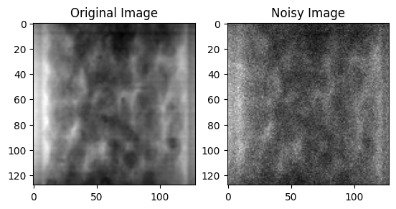

**Image after Removing Poisson (TomoGAN)**

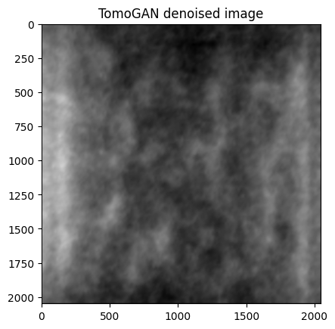

**Image after Removing Poission (CNN)**

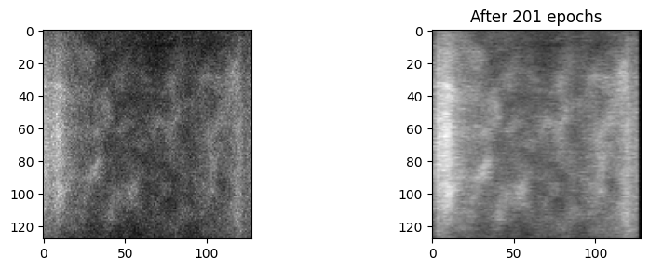

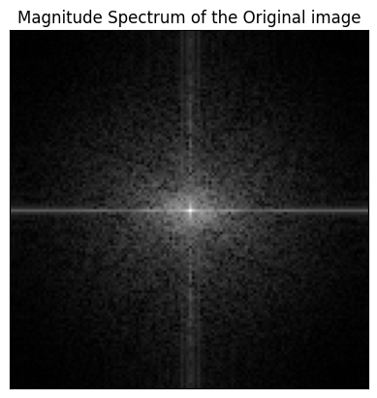

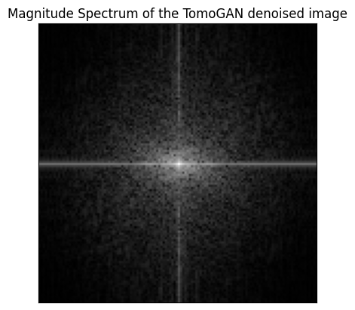

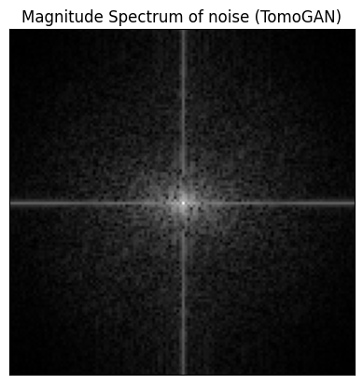

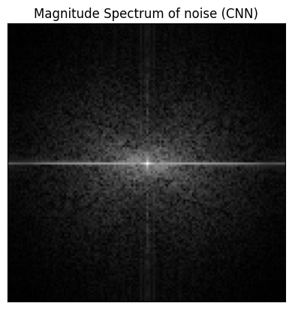

**Image Number 883 (Highest Variation):**

**Original Image:**

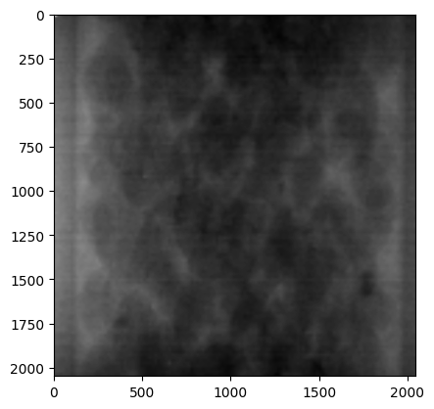

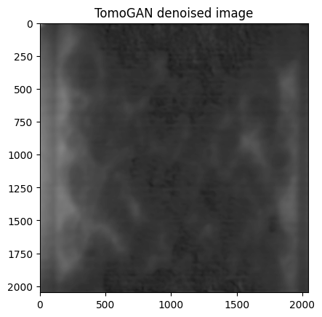

**Original and Denoised Image (CNN)**

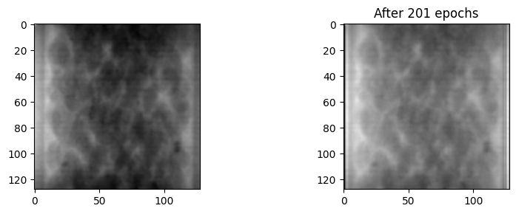

**Image of Removed Noise (TomoGAN)**

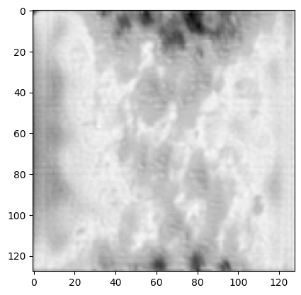

**Denoised Image (TomoGAN)**

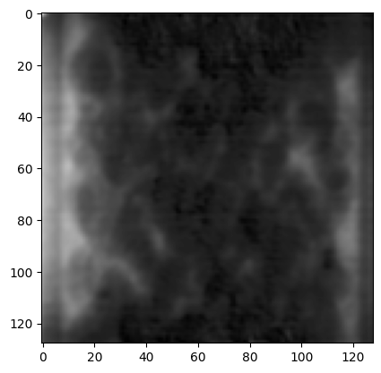

**Image of Removed Noise (CNN)**

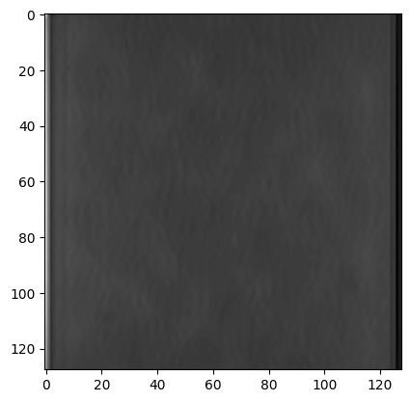

Denoised Image (CNN):

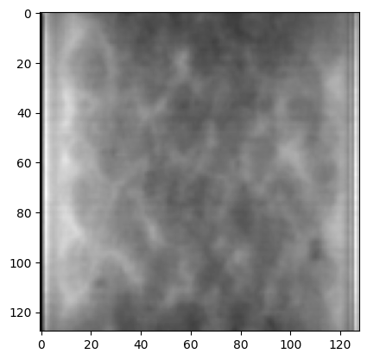

**Adding and Removing Poisson Noise:**

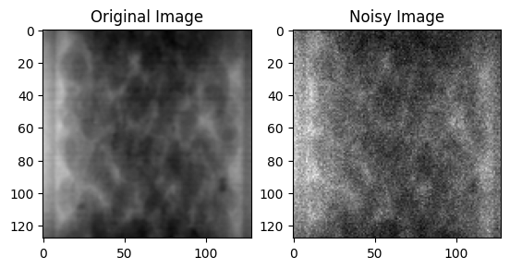

**Image after Removing Poisson (TomoGAN):**

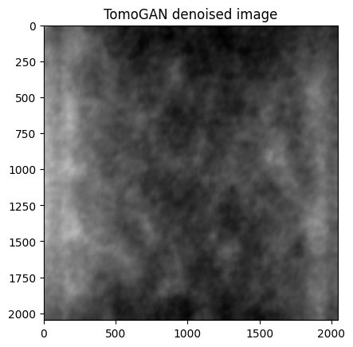

**Image after Removing Poission (CNN):**

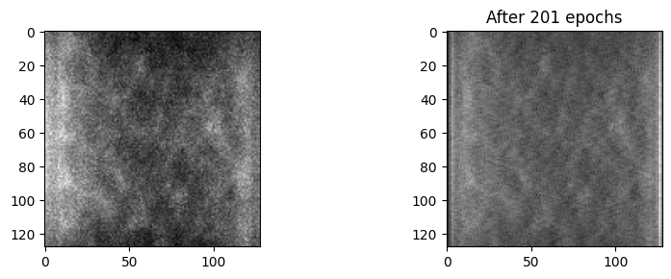

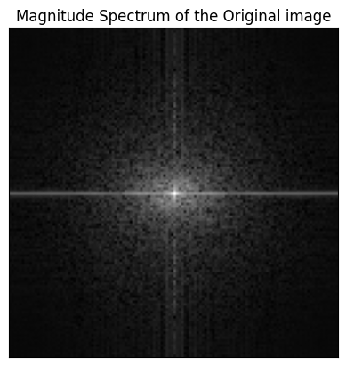

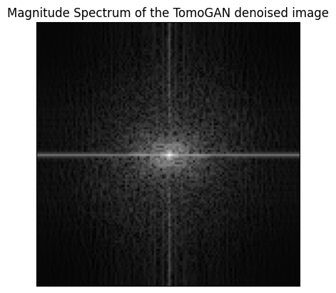

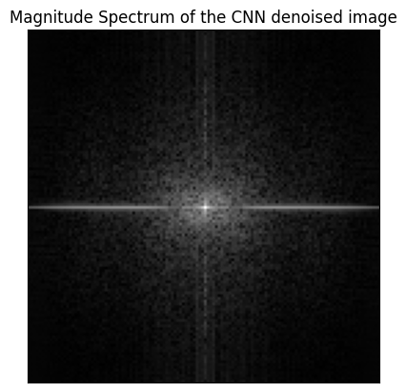

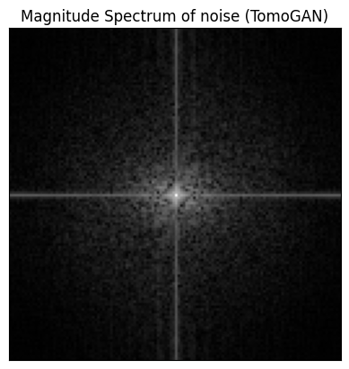

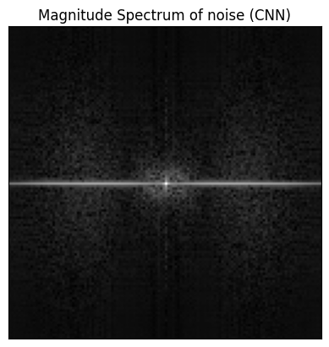

**Image Number 469 (Lowest Variation):**

**Original Image:**

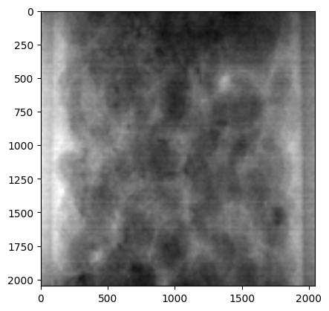

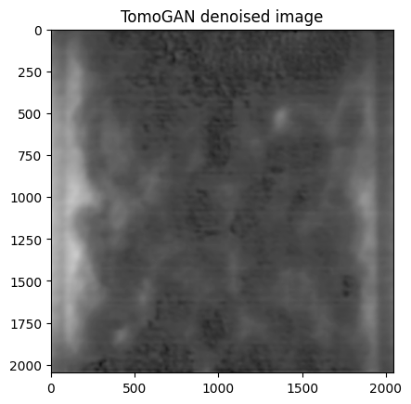

**Original and Denoised Image (CNN):**

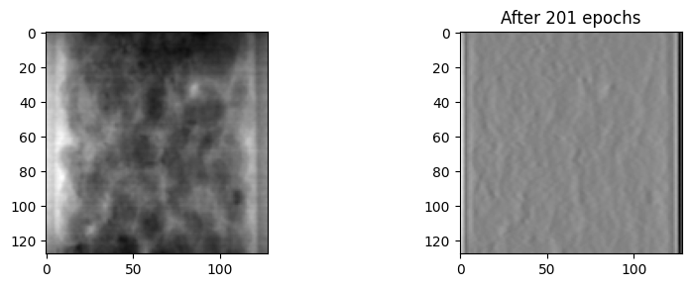

**Image of Removed Nosie (TomoGAN):**

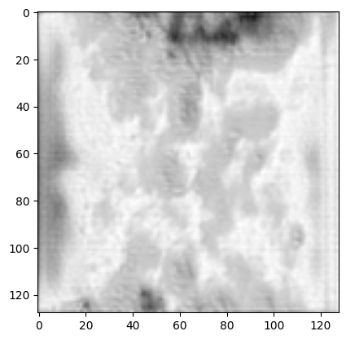

**Denoised Image (TomoGAN):**

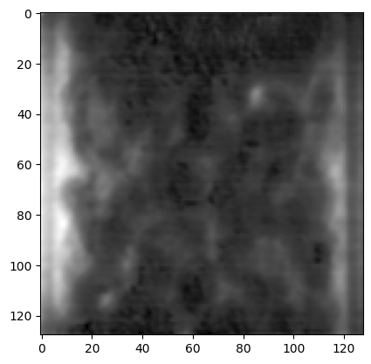

**Image of Removed Noise (CNN):**

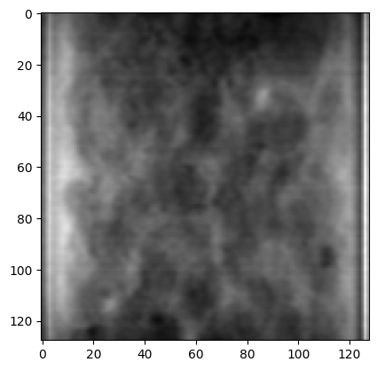

**Denoised Image (CNN)**

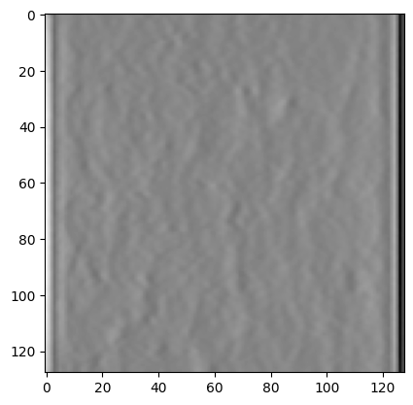

**Adding and Removing Poisson Noise:**

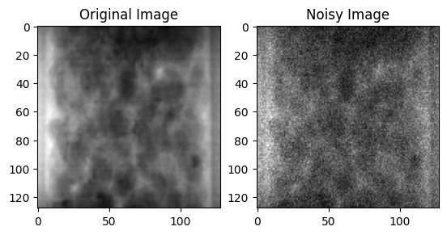

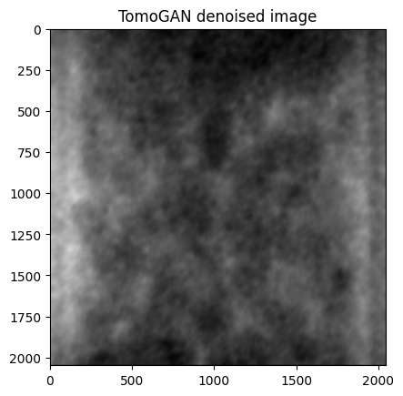

**Original and Image after Removing Poisson (CNN):**

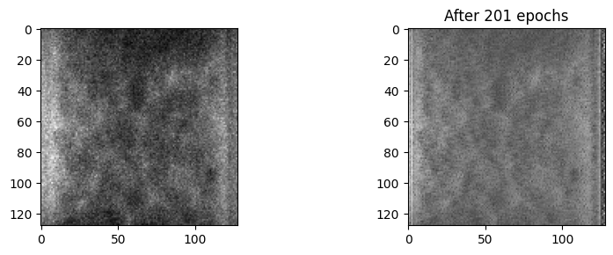

**Magnitude Spectrum:**

